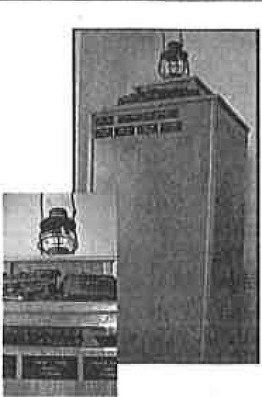

Hornell Erie Depot Museum

is *proud* to *present the* new

**HEDM** Memorial *to*

Honor the

Men and Women of the Railroad

*Support your* Museum *and* Honor *your* Railroad Family *and* Friends

To order your $25 memorial plate fill in forms below and mail with payment (cash or check only)to:

Your name: _

Address: _

Phone (in case of questions):

-----------

Email: _

Hornell Erie Depot Museum P.O. Box 5 Hornell, NY 14843

To support your museum please add additional:

$5.00_ $10.00_ $15.00_ Other_

Remember a loved one on the HEDM Memorial

L

**Your $25.00 memorial plate is 2" x 4"**

Three lines: **NAME, JOB TITLE** and **RAILROAD(s)**

Print NAME in capitals allow for spacing and punctuation **20 letter maximum:**

Print **JOB TITLE** in capitals allow for spacing and punctuation **20 letter maximum:**

Print **RAILROAD(s)** in capitals allow for spacing and punctuation **20 letter maximum:**